Models.py
The thread model has a total of five fields which are all constructed form the imported model module in the imports. The ‘thread_title’ and thread_text’ fields are both ‘CharFields’ meaning character fields having maximum lengths of 50 and 200 characters respectively. The ‘pub_date’ takes a date and outputs ‘date published’ with this given date. The ‘upvotes’ objects is an IntegerField and should be increased by one when a particular event or form is fired.
These are the imported files and objects imported that are necessary for the construction of the models. Datetime, timezone handle time of day and the calendar date when querying these objects in models. The models imported from Django are essential in the fields and construction of the models thus making this import critical. The User model is also imported due to all of the models referring to the user, with the ‘Thread’ and ‘Comment’ models referring to the user model as a ‘foreign key’ thus having a many-to-one relationship and the ‘AdditionalUserInfo’ model having a One-To-One Model
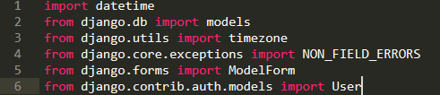
The return of the title is when the model is queried by itself and thus the set of objects within the model will be the titles of the threads.
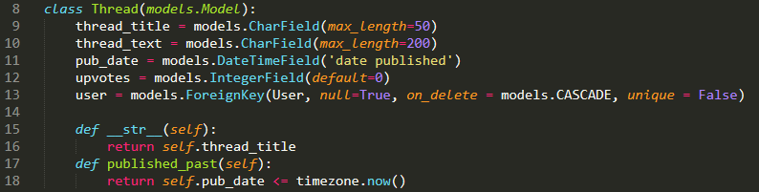
The ‘Comment’ model is the next model made. It has similar fields to the ‘Thread’ model with ‘comment_text’, ‘pub_date’, ‘upvotes’ and ‘user’ fields being similar to identical to fields in the ‘Thread’ model. However, the comment also has a foreign key being the ‘Thread’ model with the same property of the models.CASCADE on deletion of the associated model
The user field is a foreign key meaning it refers to another model. This model is the ‘User’ model provided by Django. The ‘models.CASCADE’ ensures that when the foreign key is deleted, its associated objects are deleted with it. It also is stated to be nullable and not unique
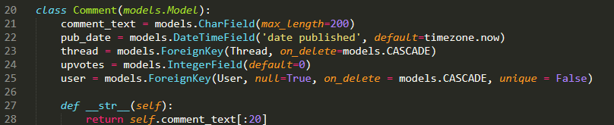
The AdditionalUserInfo Model is the last manually made model and is made to be an extension of the user model as seen by the first field; ‘models.OneToOneField(user)’ with the ‘on_delete’ property.
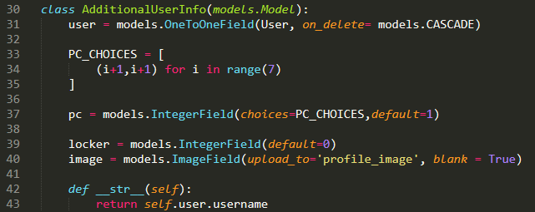
The image field is from a pip download being the ‘Pillow’ models, that allows statics and images. A directory is given with ‘upload_to’ and it can be blank
‘PC_CHOICES’ create a set with a for loop from numbers to 1 to 7 accounting for all PC’s. The ‘pc’ field than uses these choices within an ‘IntegerField’ with the default as 1. The locker field is also an ‘IntegerField’
Forms.py
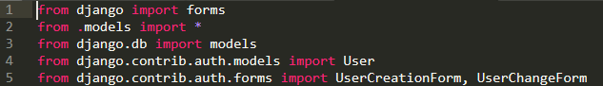
The following image shows the imports for the forms. The first import is the default Django form module which is used extensively in the construction of forms in Django. All the models are imported from the models file, ‘all’ being denoted by the star (*). Models are imported form the Django.db as well as the User model. The UserCreationForm and UserChangeForm are also imported, as there are extensions and changes made to these forms within the ‘forms.py’ file.
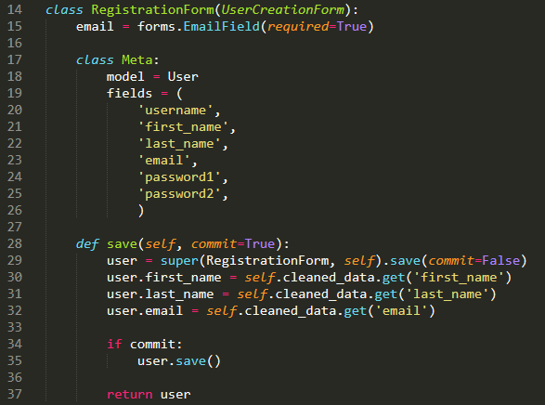
The ‘RegistrationForm’ is the first of these forms to inherit from an already made Django form as seen with ‘UserCreationForm’ being in the parameters of the class. ‘email’ is the first field extended for the form with a simple ‘EmailField’ which is set to be required. The ‘meta’ class defines the fields within a list and the model in question, being the user. The save function handles the process of saving and inputting the form information within the database using Django’s in-built functions and techniques. The user is inherited from the form with the ‘commit’ being set to false thus not fully saved. The ‘first_name’, ‘last_name’ and ‘email’ fields are defined through the form (self) with ‘cleaned_data’ using Django’s security and privacy mechanism. This form then listens in for a commit and thus will save after this commit.
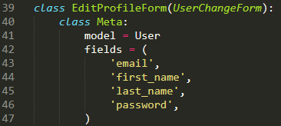
‘AdditionalUserInfoForm’ is simpler yet than the previous two in being a single field definition and referring to the ‘AdditionalUserInfo’ model. It can be seen that the parameters only include ‘forms.ModelForm’ as it does not have a form to inherit form but instead is the creation of a new form based upon a model.
The ‘EditProfileForm’ is the next inherited form (Inherited from the ‘UserChangeForm’ as seen in the parameters.. In this class, it is simple definition of the fields that is needed for this form with the fields being defined in a list as with the ‘RegistrationForm’ form.
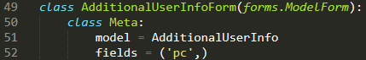
Views.py
‘HomeView’ is the first of many views and is a ‘generic view’. Generic views are set in classes and can be seen as an easier alternative to manually rendering a template. In this case, the view is a ‘ListView’ thus needing a query set. The ‘template_name’ is defined being ‘main/home.html’. The ‘context_object_name’ is defined as ‘threadset’, which will be used as context in the HTML. The view goes on with the function retrieving the list needed being the objects in the ‘Thread’ model.
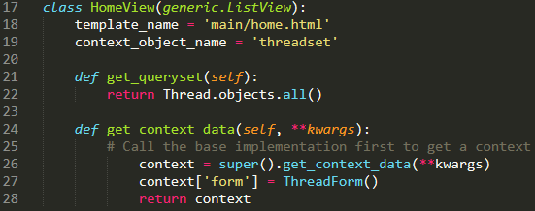
More context is defined with the ‘get_context_data’ function with ‘self’ and ‘**kwargs’ as parameters. Context is defined with first calling the ‘get_context_data’ model with arguments as ‘**kwargs’. The ‘ThreadForm’ is then defined with context[‘form’] and this is then returned.
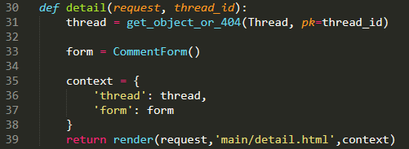
‘addComment’ uses the same parameters from the ‘detail’ view in handling requests from the ‘detail’ view. The form is defined with the request specified as ‘POST’ with ‘request.POST’. The view then proceeds to check whether the form is valid using Django’s ‘is_valid()’ function. A new comment is created with the ‘Comment model’
The following view does not refer to the output of a template as such but instead is a function handling the creation of a new comment. The ‘@require_POST’ ensures that this is only a function, as the other request ‘GET’ is used for the outputting of templates, and this is not allowed with the ‘@require_POST’.
The form for creating comments is called, simpler than the generic view being a simple definition. The context objects are then defined with the strings referring to strings within an object. ‘render’ is then used with the format of (request, target HTML page, context). In this case the HTML page is ‘main/detail.html’ and context has already been defined.
The ‘Thread’ model is called with the ‘get_object_or_404’. ‘get_object_or_404’ is self-explanatory in that it calls an objects and if it is not received a 404 error is outputted. The format of ‘get_object_or_404’ shows the model and then the primary key, in this case being the ‘Thread’ model and the ‘thread_id’ respectively.
The detail view is next and does not use the ‘generic view’ format of the previously view. It’s parameters include ‘request’ and ‘thread_id’. ‘request’ is needed in all function-based views as it calls the user requests and is fundamental for I/O in the system. ‘thread_id’ is needed as this view is used for showing objects for a particular thread, thus an id is needed for determining which thread to show.
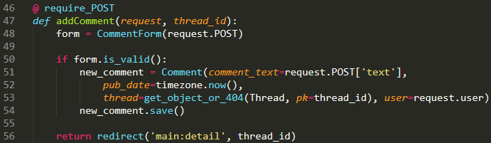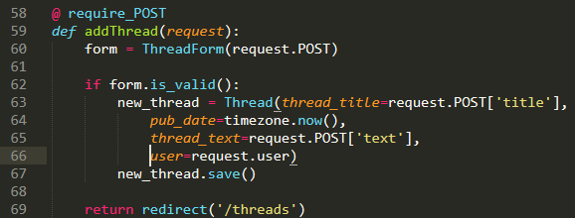
‘register’ is the next view handling the rendering of the template and the construction of the ‘User’ model both. It begins with the definition of the two forms needed being Django’s own ‘RegistrationForm’ and the extension to this being the ‘AdditionalUserInfoForm’ both requiring the request to be a ‘POST’ request. The function checks the validity of both the forms and then defines the user with ‘form.save()’. The ‘pc’ field is handled with saving the form with commit equal to ‘False’ and then defining the user before saving it completely. The username is found from the original form using the ‘get’ function to get the field in the ‘form.cleaned_data’ named ‘username’.
‘addThread’ is very similar to ‘addComment’ in using the same or very similar methods of creating a model with the exception of not needing a ‘thread’ field and adding a ‘thread_title’ from the form. This view also doesn’t need a thread_id and redirects to ‘/threads’.
The fields of the comment are listed with the comment_text being inherited from the form, the ‘pub_date’ of ‘timezone.now()’ using the current time, the ‘thread’ being defined with the thread_id and the ‘user’ being defined from the request. The comment is then saved and the functions returns a redirect to the ‘detail’ view with the ‘thread_id’ parameter.
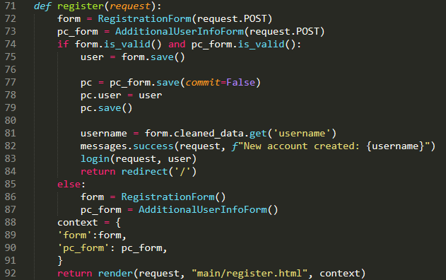
This username is used for the message which uses the ‘success’ template displaying to the request and stating the creation of a new account with the username being inputted using the ‘f’ format of string output. The user is then logged in using the Django ‘login’ module and redirected to the home page at ‘/’. If the check for validity was not valid then the forms are displayed normally with another standard render back to the register page.
The ‘view_profile’ function defines the pc_form from earlier as the user is enabled to be able to change this field. It uses the same handling of defining the user after saving without committing and then saving it, redirecting to the same page.
The context is defined with the ‘user’ being request.user and the ‘pc_form’ being the pc_form and then the template is rendered with this context and the request.
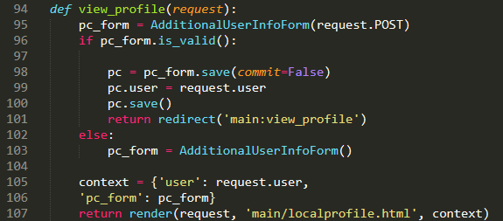
‘edit_profile’ is the next function and refers to the handling of the ‘EditProfileForm’ in the template. It first queries whether the request method is equal to ‘POST’ and if this is true the form is defined as an ‘EditProfileForm’ with the request as request.POST and the instance being the user. It then checks the validity of the form, saves it and then redirects.
If the request is not ‘POST’ then the form is displayed without the request being request.POST and the context is given with the page being rendered again with this context.
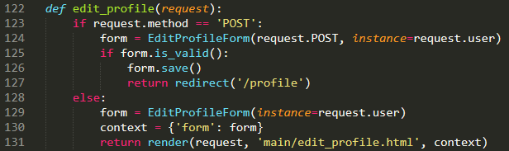
‘change_password’ is a similar function to ‘edit_profile’ as they both handle a form, the form in this case being the ‘PasswordChangeForm’. It follows a similar structure with the definition of the form being the ‘PasswordChangeForm’ with parameters ‘data’ stating the request method and the user. The validity is checked and the form is saved with the ‘updatesession_auth_hash’ updating the session of the user and it’s authentication with parameter’s request and user in the form, the user is then redirected to their profile.
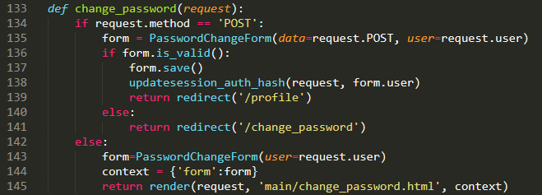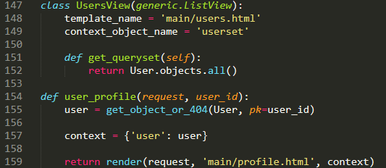
The final view described in the annotated code is the ‘user_profile’ view being relatively simple. The function takes in a request and the ‘user_id’ in being the view of a particular user. The user is defined using the ‘get_object_or_404’ function with ‘user_id’ as the primary key. The context is defined as the single field and the page is then rendered.
‘UsersView’ is another generic view thus being a class instead of a function as many were previously. This generic view is a ListView also, but it must be stated that a generic view can also be ‘DetailView’ which takes properities of an object as it’s queryset. This class defines the ‘template_name’ being the ‘users’ HTML page and defines the ‘context_object_name’ being the ‘userset’. This query set is defined using the function ‘get_queryset) returning all objects within the ‘User’ model.
If the form is invalid, the user is redirected back to the change_password template to resubmit the form. If the request method was not ‘POST’ then the page is rendered again with the context as ‘PasswordChangeForm’ taking in only the user.
Urls.py
The next file for annotation is the ‘Urls.py’ python code that handles the site hierarchy and how the views and templates are related in the context of URLs and their inter-relationships. Several objects are imported including the ‘path’ object which can be used for defining URLs in Django. ‘settings’ is imported for the purpose of checking the validity of ‘settings.DEBUG’ when handling static and media files. ‘static’ imports the object necessary for adding static files to the urlpatterns. ‘LoginView’ and ‘LogoutView’ are used for generic views and are views within Django. The views and templates are also imported.
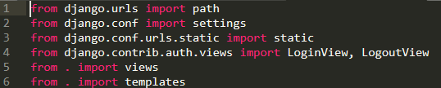
It can be seen that the views are sometimes referred to directly with views.(view) but sometimes are stated with views.(GenericView).as_view(). These are generic views and thus there can be seen a variety of normal views and generic views. Some of the views use <int:(some object’s id)>/ and this simply is an integer that is passed by a view. Such as if the first user was to be viewed at ‘main:user_profile’, it could also be called as ‘users/1/’ as the ‘id’ field of the first user would be 1.
The ‘urlpatterns’ are then defined with the ‘app_name’ stated before the ‘urlpatterns’. The ‘app_name’ is useful for a Django shortcut where if a name of a path is defined it can be called with ‘main: (name of path)’, and this can be seen in some of the views annotated previously. The ‘urlpatterns’ is a list of ‘paths’. The ‘paths’ are defined with ‘path((URL), (where the view is located), name=(name)),’
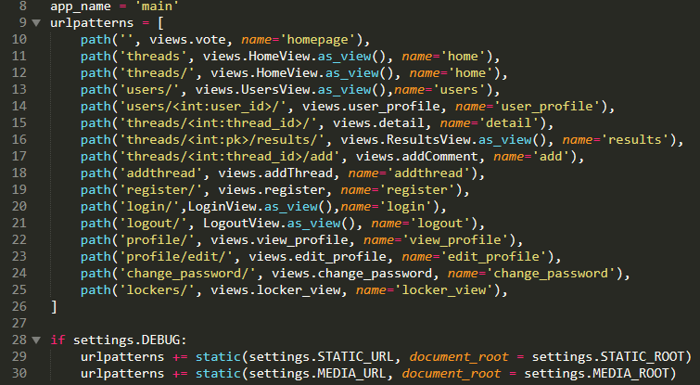
The statics are added to the urlpatterns after checking ‘if settings.DEBUG’. The static files are added with the parameters of their URL and their ‘document_root’ which are defined within the ‘SETTINGS’ file
Significant HTML Templates
Header.html
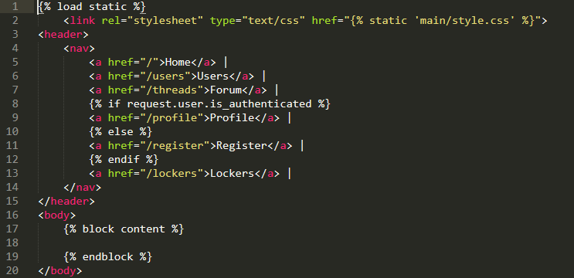
The ‘Header.html’ is the first HTML template to be annotated and is important in being a template for almost all of the other HTML files. The file begins with loading static with {% load static %} and linking the CSS stylesheet with type=’text/css’ and the reference to the directory within the app being ‘main/style.css’ encased within the static logic braces. The header is defined with a <nav> tag. Within the <nav> tag the links for the site are defined with the homepage, users page, forum hub and lockers with respective references. {% %} handles logic within Django HTML and in this case checks if the user is authenticated. If so, the profile is the available link, otherwise the link is register.
{% block content %} is important in that when extending this HTML file to other HTML files, the necessary HTML will be inputted in this block content.

Home.html (/thread) 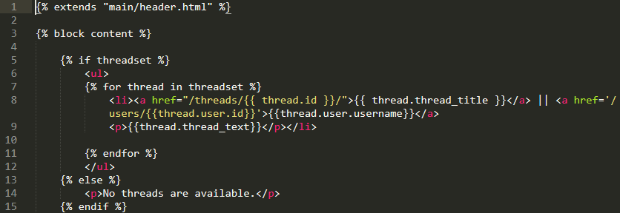
Another ‘if’ statement is used checking whether the user is authenticated. If this is true, the form is displayed within the <form> tags. The action in the form tags describe where the information will be directed and the method in this case is ‘POST’. {% csrf_token %} is used for security by Django with data being processed and transferred across the website. The fields of the form are displayed with breaks inbetween using the <br> tags. A button is inputted at the bottom for submission of this data with the <input> tag as the type as ‘submit’.

The text is outputted within paragraph tags (<p>. {% else %} deduces what happens when there is no threadset in this case. If there is no threadset then a paragraph is displayed saying there are no threads available.

‘Home.html’ is the main forum page and begins with {% extends “main/header.html” %}. This uses Django ‘extends’ to make this HTML file a part of the “header.html” and the {% block content %} within the “header.html” can be defined here. The file then refers to the ‘threadset’ as defined in the view and uses a {% for %} loop to go through each object in the threadset. It uses the <li> tag to create a new list object with <a> tags to create a hyperlink which is in this case ‘/threads/{{thread.id}}/’ as the ‘thread.id’ is correspondent to ‘/threads/<int:thread_id/’ in the URLs. The user is then linked with more <a> tags with the user being derived from the ‘Thread’ model with the user’s username then outputted.

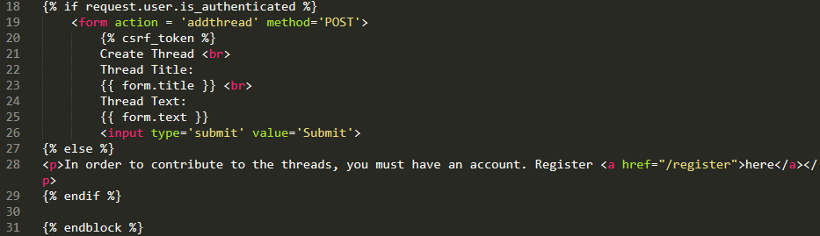
The comments in the thread are checked for existence and if there are comments, they are looped through displaying the information given the comments. The <div> tag divides the section with a style in this case being a border of 1px size being solid black. The text is then outputted in <p> tags. Prior to the output of text,

Another {% else %} statement is used for when the user is not authenticated. Within this ‘else’ statement the form is not displayed and text is displaying explaining an account is needed with a link to the registration page.

Detail.html (/thread/<int:thread_id>/)
The ‘detail.html’ is the final HTML page annotated and uses a similar structure to the ‘home.html’ in that it extends from the “main/header.html” and the information of the template is encased in the {% block content %}. The file checks for a thread and if it is found displays the information of the thread with the title being displayed as a heading with <h1> tags and a link to the user referenced by the thread followed by the brief description of a text in a paragraph tag <p>{{thread.thread_text}}</p>

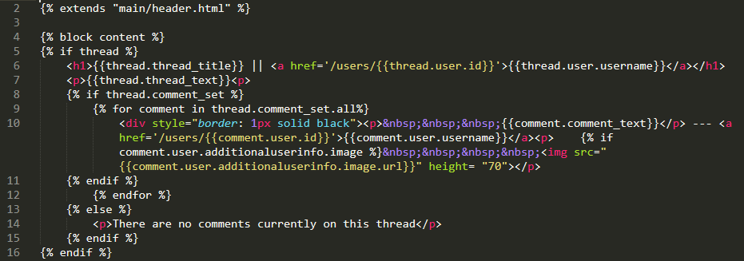
The user is then linked with the respective anchor tag and a profile image is displayed with the ‘additionaluserinfo’ of the user. This image is then given a height of 70px. An {% else %} statement used for the case of no comments and thus it is described that there are no comments on the thread selected.

Non-breaking spaces are inputted with the ‘&nbsp;’ creating a space between the border and comment, this can also be created with padding in the style

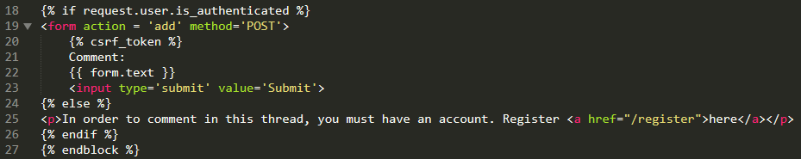
The final component of the HTML file is the form that handles the creation of a new comment. This uses a similar format to the ‘home.html’ beginning with a check for user authentication to proceed with the <form> tag if the user is authenticated. The action in this case is ‘add’, which refers to the creation of a new comment and the method is ‘POST’. A {% csrf_token %} is used before displaying the form field followed by an input button. If the user is not authenticated, a similar paragraph is displayed as ‘home.html’ describing the necessity of an account for commenting and links to the registration page.

